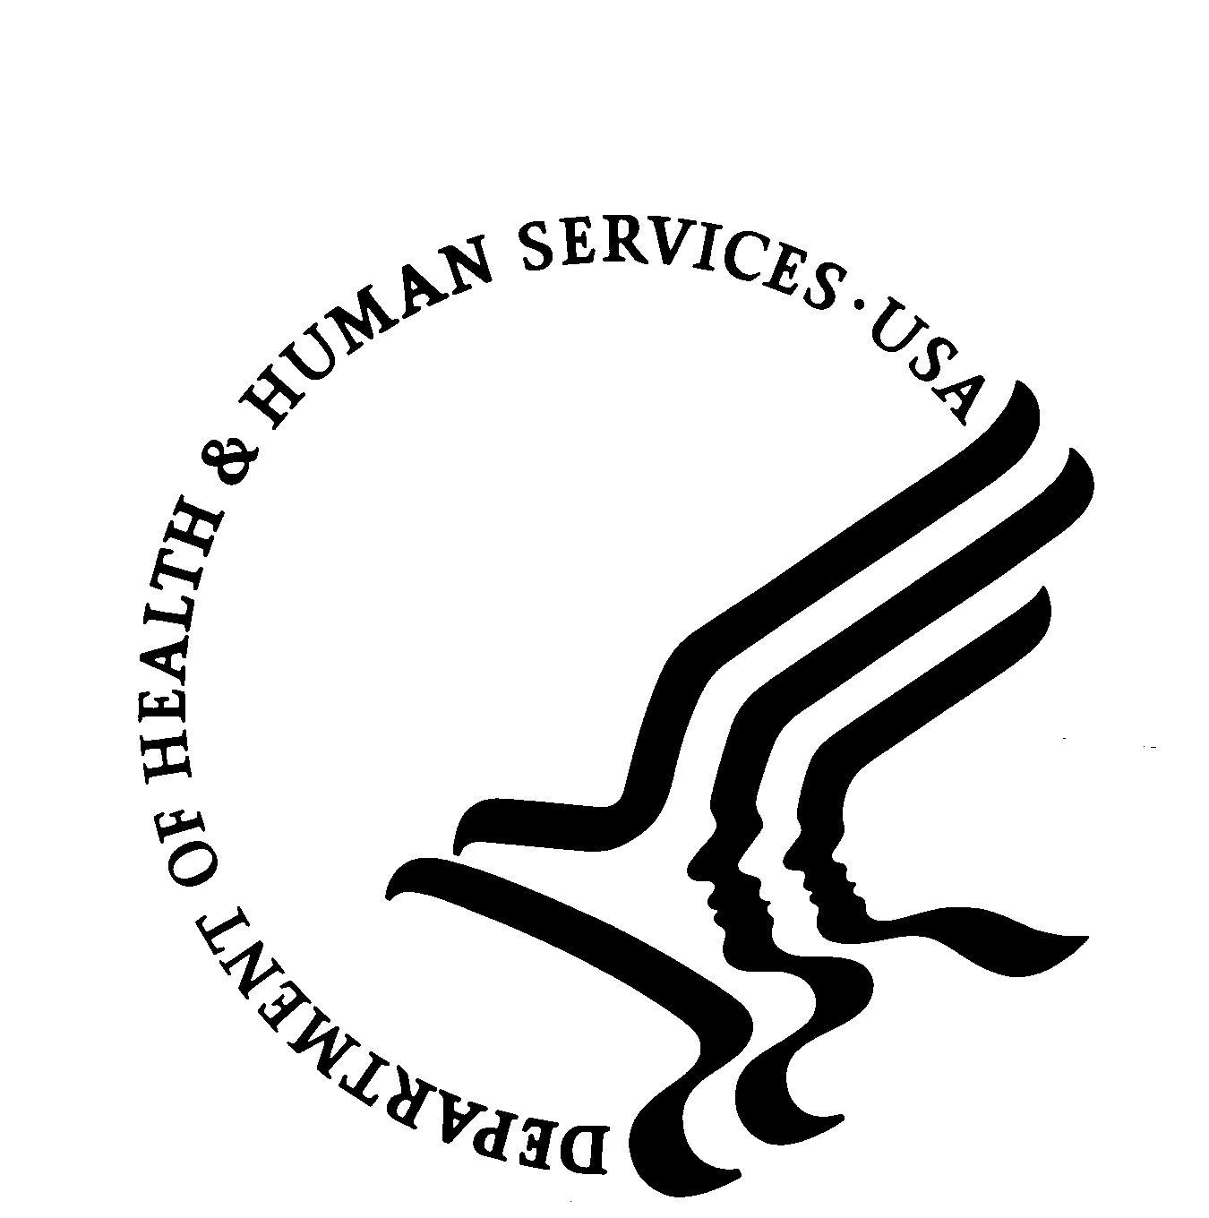

**DEPARTMENT OF HEALTH AND HUMAN SERVICES** Office of the Secretary

Office of Assistant Secretary for Health

Washington, D.C. 20201

July 1, 2025

**OASH Teen Pregnancy Prevention Program Policy Notice**

**Release Date: July 1, 2025**

**OASH Program Policy Notice: 2025 - 01**

**Purpose**

The purpose of this Program Policy Notice (PPN) is to clarify OASH policy for Teen Pregnancy Prevention Program (TPP Program) grant recipients, to delineate when materials and activities are not “medically accurate,” “age appropriate,” do not “reduce teen pregnancy,” or are otherwise outside the scope of the TPP Program. This PPN also clarifies TPP Program grant recipients’ obligations to protect parents’ rights to direct the religious upbringing of their children consistent with *Mahmoud v. Taylor,* 606 U.S. ___ (2025). Additionally, this PPN outlines evaluation standards for TPP Program grant recipients and evidence-based programs (EBPs). The PPN applies to TPP Program grant recipients, subrecipients, and service sites, and clarifies provisions contained in previous Notice of Funding Opportunities (NOFO), including AH-TP1-23-001 and AH-TP2-23-002.

Consistent with the preexisting obligations of recipients of TPP funds, HHS notified recipients in the “Guidance for Preparing a Non-Competing Continuation Award Application” (NCC guidance) that they should revise their projects to align with Executive Orders that are currently in force as necessary in order to receive continuation funding. The NCC guidance stated as follows:

Recipients are expected to review and be aware of current [Presidential Executive Orders](https://www.whitehouse.gov/presidential-actions/executive-orders/). Recipients are expected to revise their projects, as necessary, to demonstrate that the NCC award application is aligned with current Executive Orders. Recipients should review and be aware of all current Presidential Executive Orders; however, the following may be of most relevance to the work of the TPP program:

* [Executive Order 14168](https://www.federalregister.gov/executive-order/14168) *Defending Women From Gender Ideology Extremism and Restoring Biological Truth to the Federal Government*
* [Executive Order 14190](https://www.federalregister.gov/executive-order/14190) *Ending Radical Indoctrination in K-12 Schooling*
* [Executive Order 14187](https://www.federalregister.gov/executive-order/14187) *Protecting Children From Chemical and Surgical Mutilation*
* [Executive Order 14151](https://www.federalregister.gov/executive-order/14151) *Ending Radical and Wasteful Government DEI Programs and Preferencing*
* [Executive Order 14173](https://www.federalregister.gov/documents/2025/01/31/2025-02097/ending-illegal-discrimination-and-restoring-merit-based-opportunity) *Ending Illegal Discrimination and Restoring Merit-Based Opportunity*

The NCC guidance further clarified provisions of the NOFO AH-TPI-23-001 and AH-TP2-23-002, requiring OASH to review to ensure that “NOFO expectations are being met, to the extent aligned with Presidential Executive Orders: *Teen Pregnancy Prevention (TPP) Program Recipients (Tier 1: AH-TPI-23-001)*.”

In light of recent Presidential Executive Orders, Supreme Court decisions, current court orders, and the NCC guidance, OASH issues this PPN to further clarify these expectations for TPP Program grantees.

**Statutory Language**

TPP Program grant recipients must comply with the requirements set out in the statutory language of the annual HHS Appropriations Act (e.g., Division D of the Further Consolidated Appropriations Act, 2024 (Pub. L. No. 118-47)) (referenced herein as the statute):

That of the funds made available under this heading, $101,000,000 shall be for making competitive contracts and grants to public and private entities to fund medically accurate and age appropriate programs that reduce teen pregnancy and for the Federal costs associated with administering and evaluating such contracts and grants, of which not more than 10 percent of the available funds shall be for training and technical assistance, evaluation, outreach, and additional program support activities, and of the remaining amount 75 percent shall be for replicating programs that have been proven effective through rigorous evaluation to reduce teenage pregnancy, behavioral risk factors underlying teenage pregnancy, or other associated risk factors [Tier 1 programs], and 25 percent shall be available for research and demonstration grants to develop, replicate, refine, and test additional models and innovative strategies for preventing teenage pregnancy [Tier 2 programs].

**Ending Radical Indoctrination of Youth and Protecting Parental Rights**

President Trump’s Executive Order 14190, *Ending Radical Indoctrination in K-12 Schooling*, referenced in the NCC guidance, establishes a clear Federal policy against indoctrinating our nation’s youth and blocking parental oversight:

Parents trust America’s schools to provide their children with a rigorous education and to instill a patriotic admiration for our incredible Nation and the values for which we stand.

In recent years, however, parents have witnessed schools indoctrinate their children in radical, anti-American ideologies while deliberately blocking parental oversight.  Such an environment operates as an echo chamber, in which students are forced to accept these ideologies without question or critical examination.  In many cases, innocent children are compelled to adopt identities as either victims or oppressors solely based on their skin color and other immutable characteristics.  In other instances, young men and women are made to question whether they were born in the wrong body and whether to view their parents and their reality as enemies to be blamed.  These practices not only erode critical thinking but also sow division, confusion, and distrust, which undermine the very foundations of personal identity and family unity.

Imprinting anti-American, subversive, harmful, and false ideologies on our Nation’s children not only violates longstanding anti-discrimination civil rights law in many cases, but usurps basic parental authority.

TPP Program-funded projects should not undermine the President’s clear policy directive to protect children from harmful ideologies or the constitutional rights of parents to direct the religious upbringing of their children. *Mahmoud v. Taylor,* 606 U.S. ___ (2025), slip. op. at 1, 18-19; *id.* (op. of Thomas, J., concurring) at 6-7; *Wisconsin v. Yoder*,406 U.S. 205, 232-33 (1972)*.* This policy is also consistent with the limited scope of the TPP Program statute.

In *Mahmoud,* the Supreme Courtreviewed certain children’s books considered to be “LGBTQ+-inclusive” and found the books were “designed to present certain values and beliefs as things to be celebrated, and certain contrary values and beliefs as things to be rejected.” *Id.* at 22. The Court determined that this content—combined with the “decision to withhold notice to parents and to forbid opt outs”—“substantially interferes with [parents’] religious development of their children and imposes the kind of burden on religious exercise that *Yoder* found unacceptable.” *Id.* at 21-22. The Court determined that the content at issue portrayed messages and images about same-sex marriage and gender ideology that “impose[d] upon children a set of values and beliefs that are hostile to their parents’ religious beliefs.” *Id.* at 25 (internal quotation marks omitted). Just as “[p]ublic education is a public benefit,” so also OASH seeks to make clear its expectation that, consistent with *Mahmoud,* federal funding provided through the TPP Program will not be conditioned “on parents’ willingness to accept a burden on their religious exercise.” *Id.* at 32-33. In order not to “burden[] [] parents’ right to the free exercise of religion” with respect to their minor children, *id.* at 35, TPP Program grant recipients are expected to provide parents advance notice (including relevant specifics) and the ability to opt out of any content or activities, especially those related to sexuality, that may burden their religious exercise.

**Scope of the TPP Program**

Programs cannot be funded under the TPP Program if they include materials or activities (including any ancillary supportive services), whether provided by the grantee or by referral, that are inconsistent with, or beyond the scope of, the statutory requirements for TPP programs: (1) to be “medically accurate and age appropriate programs that reduce teen pregnancy,” (2) in the case of Tier 1 grantees, to replicate EBPs that “reduce teenage pregnancy, behavioral risk factors underlying teenage pregnancy, or other associated risk factors,” and (3) in the case of Tier 2 research and demonstration grantees, “to develop, replicate, refine, and test additional models and innovative strategies for preventing teenage pregnancy.”

The statute funds programs to reduce teenage pregnancy (including behavior risk factors underlying teenage pregnancy or other associated risk factors), and it makes no mention of ideological content such as the content at issue in *Mahmoud*, gender ideology, or discriminatory equity ideology (as such terms are defined in Executive Order 14190). The statute does not require, support, or authorize teaching minors about such content, including the radical ideological claim that boys can identify as girls and vice versa. Programs must be aimed at reducing teen pregnancy, not instructing in such ideological content. That *Mahmoud* reaffirms that federal funding cannot be conditioned “on parents’ willingness to accept a burden on their religious exercise” confirms that the best reading of the TPP statute does not contemplate such ideological content.

By the same token, material or instruction outside the scope of the TPP Program may include other content that is not related to, or counter to the aim of, reducing teen pregnancy, such as content that encourages, normalizes, or promotes sexual activity for minors, including anal and oral sex, or masturbation, including through sexually themed roleplay. This also may include content on the eroticization of birth control methods, creating more pleasurable sexual experiences, or foreplay techniques.

**Definitions**

OASH is concerned that the below definitions in the NOFO AH-TPI-23-001 include deficiencies based on the statutory language and Congressional intent of the TPP Program:

Adolescent-friendly services - Services for youth that are equitable, accessible, acceptable, appropriate, and effective.

Age appropriateness - Ensures that topics, messages, and teaching methods are suitable to particular ages or age groups of children and adolescents, based on developing cognitive, emotional, and behavioral capacity typical for the age or age group. An age-appropriate program addresses students’ needs, interests, concerns, developmental and emotional maturity levels, experiences, and current knowledge and skill levels. Learning is relevant and applicable to students’ daily lives and concepts and skills are covered in a logical sequence.

Equitable environment - Ensures youth have equal access to and rights to the same opportunities and resources as others.

Health equity - The attainment of the highest level of health for all people. Achieving health equity requires valuing everyone equally with focused and ongoing societal efforts to address avoidable inequalities, historical and contemporary injustices, and the elimination of health and health care disparities.

Inclusivity - When all people, especially youth, are fully included, supported, and can actively participate in and benefit from the information they need to make healthy choices. This includes ensuring that program materials and practices do not alienate, exclude, or stigmatize individuals of diverse lived experiences and backgrounds, which includes but is not limited to, individuals who belong to underserved communities, such as Black, Latino, and Indigenous and Native American persons, Asian Americans and Pacific Islanders and other persons of color; members of religious minorities; lesbian, gay, bisexual, transgender, and queer (LGBTQ+) persons; persons with disabilities; persons who live in rural areas; and persons otherwise historically marginalized and adversely affected by persistent poverty or inequality.

Medical accuracy - Verified or supported by the weight of research conducted in compliance with accepted scientific methods; and published in peer-reviewed journals, where applicable or comprising information that leading professional organizations and agencies with relevant expertise in the field recognize as accurate, objective, and complete.

OASH seeks to clarify these definitions:

“Age appropriate” programs for minors do not contain material that depicts, describes, exposes or presents obscene, indecent, or sexually explicit content. Material or instruction that is not age appropriate for minors may include content that promotes sexual activity for minors, described above, which is also outside the scope of the TPP Program for other reasons.

OASH will determine whether program content is “medically accurate” consistent with the statutory language. “Medically accurate” materials or instructions with pharmaceutical or health-related recommendations are expected to include information on a full range of health risks, so that minors and their parents or guardians can make fully informed decisions. Content that is not “medically accurate” may include inaccurate information about methods of contraception, including associated health risks, or information that denies the biological reality of sex or otherwise fails to distinguish appropriately between males and females, such as for the purpose of body literacy.

The terms “health equity,” “equitable environment,” “inclusivity,” and “adolescent-friendly services” should not be construed to exceed the statutory scope of the TPP program, as described above, or to permit unlawful diversity, equity, or inclusion-related discrimination.

**Compliance**

TPP Program grant recipients agree to comply with Department regulations and policies in their grant terms, and those determined noncompliant with the PPN may face grant suspension under 45 C.F.R. § 75.371 and grant termination under 45 C.F.R. § 75.372(a) before October 1, 2025, and, starting October 1, 2025, termination under2 CFR §§ 200.340(a)(1)-(4).

Materials or activities outside the TPP Program’s statutory scope, including those that are not “medically accurate,” “age appropriate,” or are unrelated to reducing teen pregnancy, as described in this PPN, and any expenditures associated therewith are not allowable, reasonable, or allocable to programs that include such content. *See* 45 C.F.R. §§ 75.403-405. TPP Program grant recipients are expected to ensure all program materials comply with this PPN. We are aware that curricula and other program materials—including content disqualified herein as not “medically accurate” or not “age appropriate” or unrelated to reducing teen pregnancy—were previously approved by OASH, and we have taken that into account in weighing factors relating to this policy notice. However, for the reasons described above, the prior administration erred in approving such materials and that approval exceeded the agency’s authority to administer the program consistent with the legislation as enacted by Congress. We understand that compliance with this PPN may require some grantees to revise their TPP Program curricula and content. However, the need to comply with the statutory requirements of the TPP Program, Presidential Executive Orders, and the U.S. Constitution outweighs such burdens. *See* 45 C.F.R. § 75.303(b) (requiring compliance with all Federal statutes, regulations, and the terms and conditions of the Federal award), §§ 75.403-405 (requiring grant expenditures to be reasonable and allocable in order to be allowable). The NOFOs AH-TPI-23-001 and AH-TP2-23-002 additionally required applicants to certify that they “[w]ill comply with all applicable requirements of all other federal laws, executive orders, regulations, and public policies governing financial assistance awards…” The NOFOs also informed applicants that they “must comply with all terms and conditions outlined in the Notice of Award… [including] requirements imposed by program statutes and regulations and HHS grant administration regulations, as applicable...”

OASH will not continue to fund materials or activities outside the TPP Program’s statutory scope. OASH may re-evaluate the effectiveness of programs consistent with the statutory text and this PPN. OASH may impose additional conditions on grantees that fail to comply with any Federal statutes, regulations or terms and conditions that apply to their awards. *See* 45 C.F.R. § 75.371.